

200 Wellington Street, P.O. Box 2019, Sarnia Ontario N7T 7L2 Phone: 519-336-1500 or 1-800-754-7125

Fax: 519-336-0992

Month XX, 2018

Dear Parent/Guardian,

I am writing today to make you aware of test results for water sampling completed at Colonel Cameron School. Under Regulation 243/07, school boards and child care providers are required to flush the plumbing in schools and child care centres; sample and test the drinking water for lead content; as well as maintain logs and report drinking water results to the Ministry of Environment and Climate Change.

During the sampling at the school, a test result indicated lead levels exceeded the Ministry guidelines. In the event that levels of lead exceed Ministry guidelines in a water sample, the Ministry of Environment and Climate Change and the local public health officials are notified and the Lambton Kent District School Board (LKDSB) follows the direction of the Medical Officer of Health for corrective action and resolution.

The health and safety of our students, staff and visitors to our buildings is a top priority and we worked with local public health officials to resolve the issue. Where appropriate, signage was posted and communication provided to students and staff regarding any drinking water fixture taken out-of-service until the issue is resolved. Corrective actions could include re-sampling and increasing frequency of flushing; installing a lead reducing filter; replacing a fixture; or permanently rendering a fixture unusable.

Under Regulation 243/07, samples are collected and tested for lead content at every drinking water fountain and every tap that is used in the preparation of food or drink, or to provide drinking water for consumption by children under 18 years of age. Fixtures not used for drinking water, such as bathroom taps and hand sinks in classrooms, are not required to be tested and are labelled with signage indicating that the water is not to be consumed and is for “Handwashing Only.”

The school’s waterlines are flushed weekly or daily, each day the school and/or child care is open. The frequency depends on factors such as age of the plumbing and test results.

We appreciate your support as the LKDSB works to implement the corrective actions to further safeguard the quality of the drinking water in our schools. If you have any questions related to the flushing, sampling, or testing, please contact your principal.

Complete water testing reports are available for viewing at the school and additional information, including a summary report of LKDSB facilities with lead exceedances, is published on the LKDSB website: (insert link)

Sincerely,

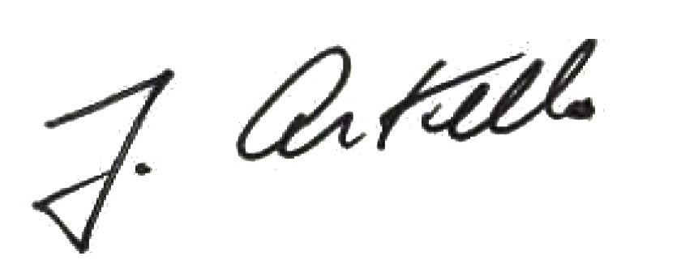

Jim Costello

Director of Education